***ANALYSIS OF INDIAN YOUTUBE DATA***

1. **How much time a video takes to trend on IN youtube?**

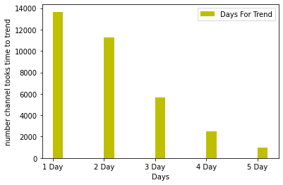

* **As we can see that most of youtube videoes takes only one day to trend .**
* **It takes maximum 5 days to trend video on youtube.**

**2)Name of the channel who have most viewed video.**

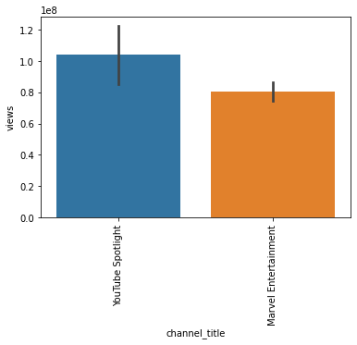

* **From the above analysis we can say that there two channel has most viewed on their video**
* **The channel’s name is**

**1)YouTube Spotlight**

**2)Marvel Entertainment**

**3) Which kind of categories video uploaded on youtube most?**

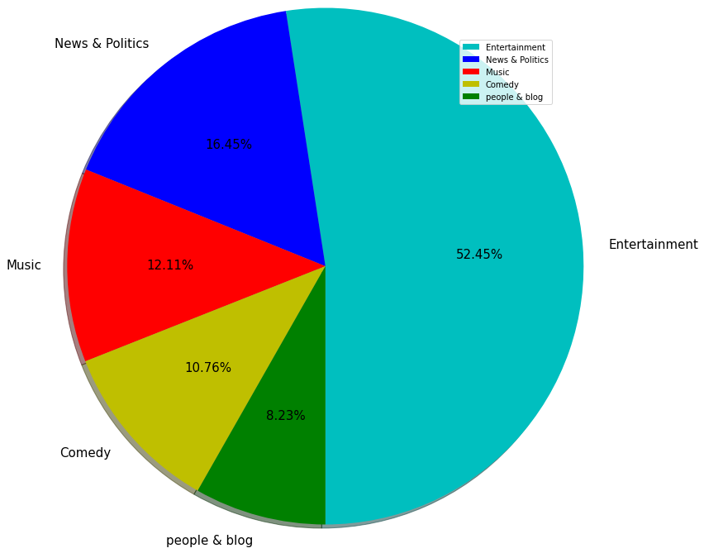

* The most of video uploaded on YouTube is Entertainment type of video ,Nearly 53% videoes uploaded on youtube is entertainmaint video.
* 16.45% videoes uploaded on youtube is News & Political type.
* 12.11% videoes uploaded on youtube is Musical.
* 10.76% uploaded video on youtube is Comedy.
* And 8.23% uploaded video on youtube is about People & Blog.

(I have just analyse just major categories of youtube .And the data is based on past entries.)